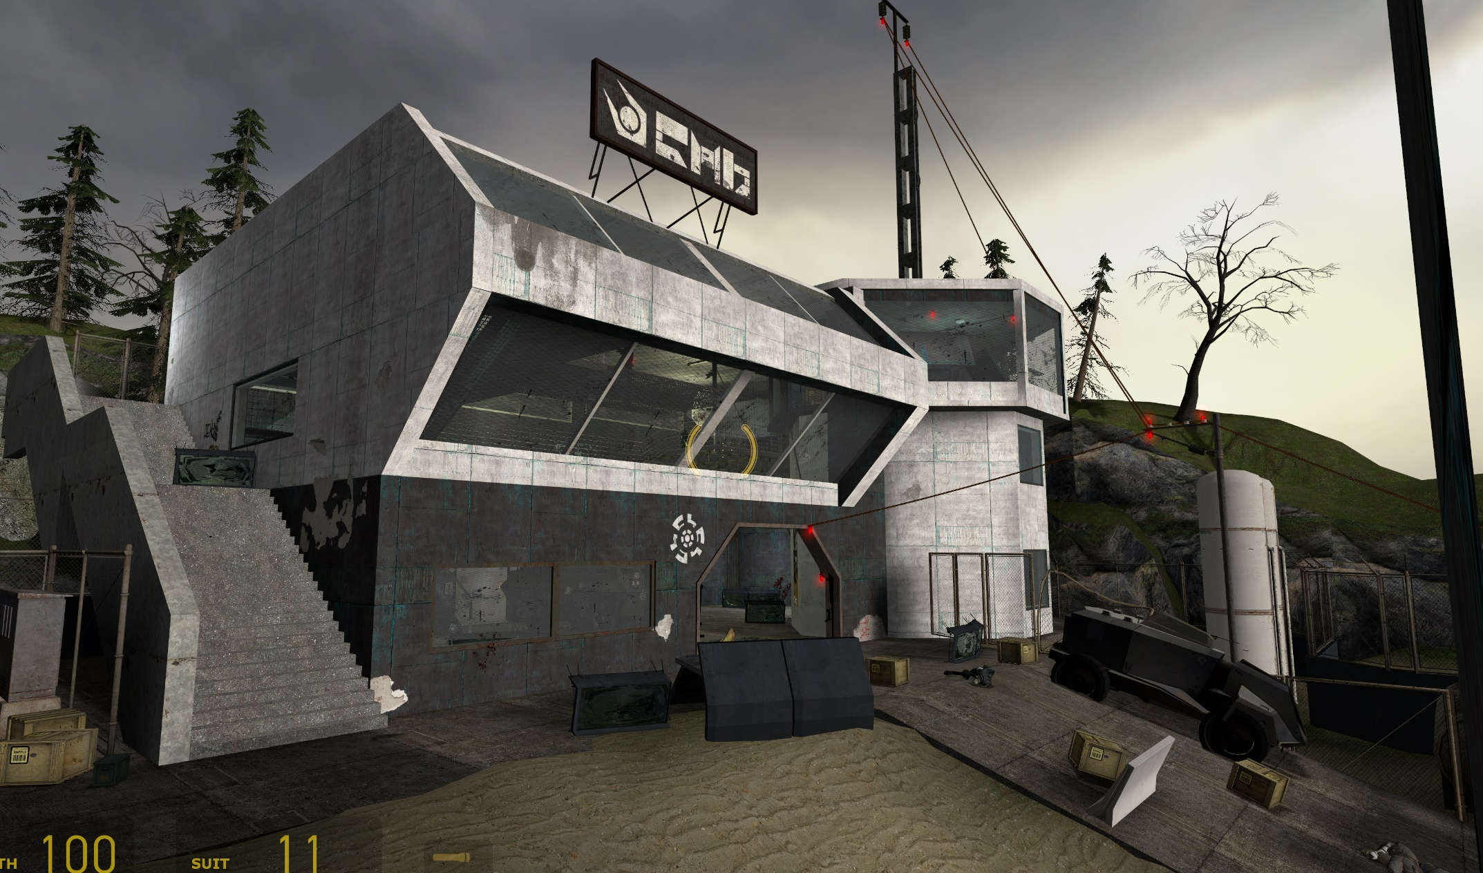
Figure 1: Cover Image [1]

Half-Life 2: Antlion Rescue
  - Version 2.0
Designer: | Jiafan “Roy” LU
Document Date: | 12/11/2024
Level Delivery Date: | 12/8/2024

Document Revisions Table
Version | Description | Requestor | Date
1.0 | Initial Document | Professor Myque Ouellette | 11/3/2024
2.0 | Final Document  - Updated Level Summary  - Updated the Level Feature Overview and make it more specific  - Updated the Walkthrough level to the Launch Version  - Updated the SPC, the level’s sections have been subdivided, and more categories have been added  - Added two real world aesthetics reference images for the Visual Theme  - Removed the Bio-pod Puzzle in Appendix A  - Made the location of the level in the HL2 more specific in the Appendix B  - Added more details in the Appendix E about the risks  - Added some potential solutions for the material issues in Appendix F | Professor Myque Ouellette | 12/11/2024

Table of Contents
Table of Contents 3
Table of Figures 4
Level Summary 5
Quick Summary 5
Level Feature Overview 6
Development Schedule 7
Level Overview 8
Overview Map 8
Level Details 10
Detail Maps 10
Section 1: Coast Beach 10
Section 2: Combine Garage 12
Section 3: Building 14
Section 4: Facility Exit Gate 17
Skill Progression Chart 19
Aesthetic References 20
Visual Theme 1: Coast Light source and Layout 20
Visual Theme 2: Military Facility 21
References 22
Appendices 23
Appendix A: New Skills / Gameplay Mechanics 23
Command the Antlion to destroy the Diesel Generator and Obstacles 23
Appendix B: Context Detail 24
General Context 24
Backstory 24
Aftermath 24
Appendix C: Character Descriptions 25
NPC 1 25
Appendix D: Dialog Flow 26
NPC 1 26
Appendix E: Development Risks 27
Appendix F: Key Asset Needs 28

Table of Figures

Figure 1: Cover Image [1] 1
Figure 2: Overview Map Walkthrough [2,3] 8
Figure 3: Section 1 Coast Beach Map Walkthrough [2,3] 10
Figure 4: Section 2 Garage Walkthrough [2,3] 12
Figure 5: Section 3 Combine Building Walkthrough [2,3] 14
Figure 6: Building Exit to Facility Exit Walkthrough [2,3] 17
Figure 7: Antlion Rescue Level Skill Progression Chart [4] 19
Figure 8: Coast Beach Scene Contact Sheet [5,6,7] 20
Figure 9: Interior of the building Contact Sheet [8,9,10] 21

Level Summary

Quick Summary
Antlion Rescue is a single-player level of Half-Life 2, set in the sixth chapter of Half-Life 2, after Gordon Freeman acquires the Pheropod.
Today, Antlion has become a solid ally of the Resistance. Gordon Freeman and an Antlion are sent by the Resistance to the coast to eliminate enemies in a Combine facility. Players need to use the Pheropod to control a trained Antlion in the level, which can help the player defeat enemies, clear rock obstacles in the way, and reach areas that the player cannot access by flying. As the player, you can use the gravity gun to pick up objects to create pathways, operate buttons on panels to disable Thumpers or Combine Fence to allow yourself and the Antlion to infiltrate the facility successfully.

Level Feature Overview
Category | Sub-Category | Feature List
Gameplay Themes | AI Control (Antlion Commander) | - Command the Antlion for killing enemies
Gameplay Themes | AI Control (Antlion Commander) | - Command the Antlion to clear obstacles
Gameplay Themes | AI Control (Antlion Commander) | - Command the Antlion to get to some high place that the players can’t reach to by themselves and solve puzzles there
Player | Player Weapons | Start With:  - Pheropod  - Shotgun  - MP7  - Gravity Gun
 | Player Skills/Abilities | - Controlling the Antlion  - Using Gravity Gun to pick up objects  - Using the Button on the Combine Interface to control the Thumpers or Combine Fences
AI | Enemies | - Combine Soldier with MP7  - Metropolice with MP7 and Manhack  - Manhack
AI | Friendlies | - Antlions
Challenges | Obstacles/Hazards | - Thumpers  - Water  - Wooden barricades  - Breakable Glass
 | New/Unique Gameplay | - Shut down Thumper so that the Antlion can pass through  - Build bridge above water so that the Antlion can pass through  - Command Antlions to clear obstacles
Context | Location in Game | - After Chapter 6 Sandtraps when Gordon Freeman got the Pheropod and was able to control the Antlion Soldiers
Context | Challenge Fit in Game | - Considering the challenge, this level can be set between Sandtraps and Nova Prospekt, after the player has mastered the use of the Pheropod
Context | Narrative Fit | - This level can be set before Freeman and Alyx use the teleporter to escape Nova Prospekt, because after that, the game transitions to the city scene, with no sand for Antlions to spawn.
Context | Basic Backstory / Results Info | - Freeman teams up with a trained Antlion to infiltrate and destroy a Combine facility
Aesthetics | Major Visual Themes | - Abandoned Port  - Coast  - Combine Storage and Garage
 | Setting/Mood | - The lighting is Dim and the atmosphere is cold  - A dilapidated, rusty, abandoned port that has been occupied and transformed by the Combine.

Development Schedule
Milestone | Date
LDD | 11/3/2024
Whitebox | 11/10/2024
Initial Gameplay | 11/17/2024
Gameplay Complete | 11/24/2024
Aesthetics | 12/1/2024
Launch | 12/8/2024

Level Overview

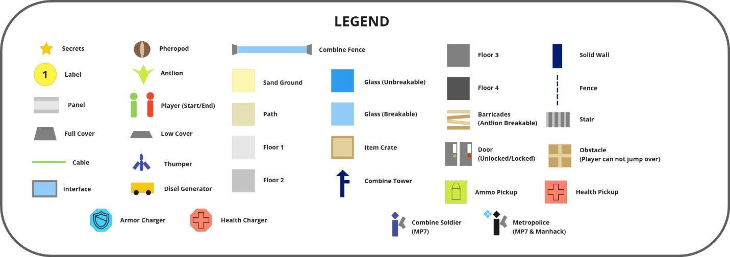
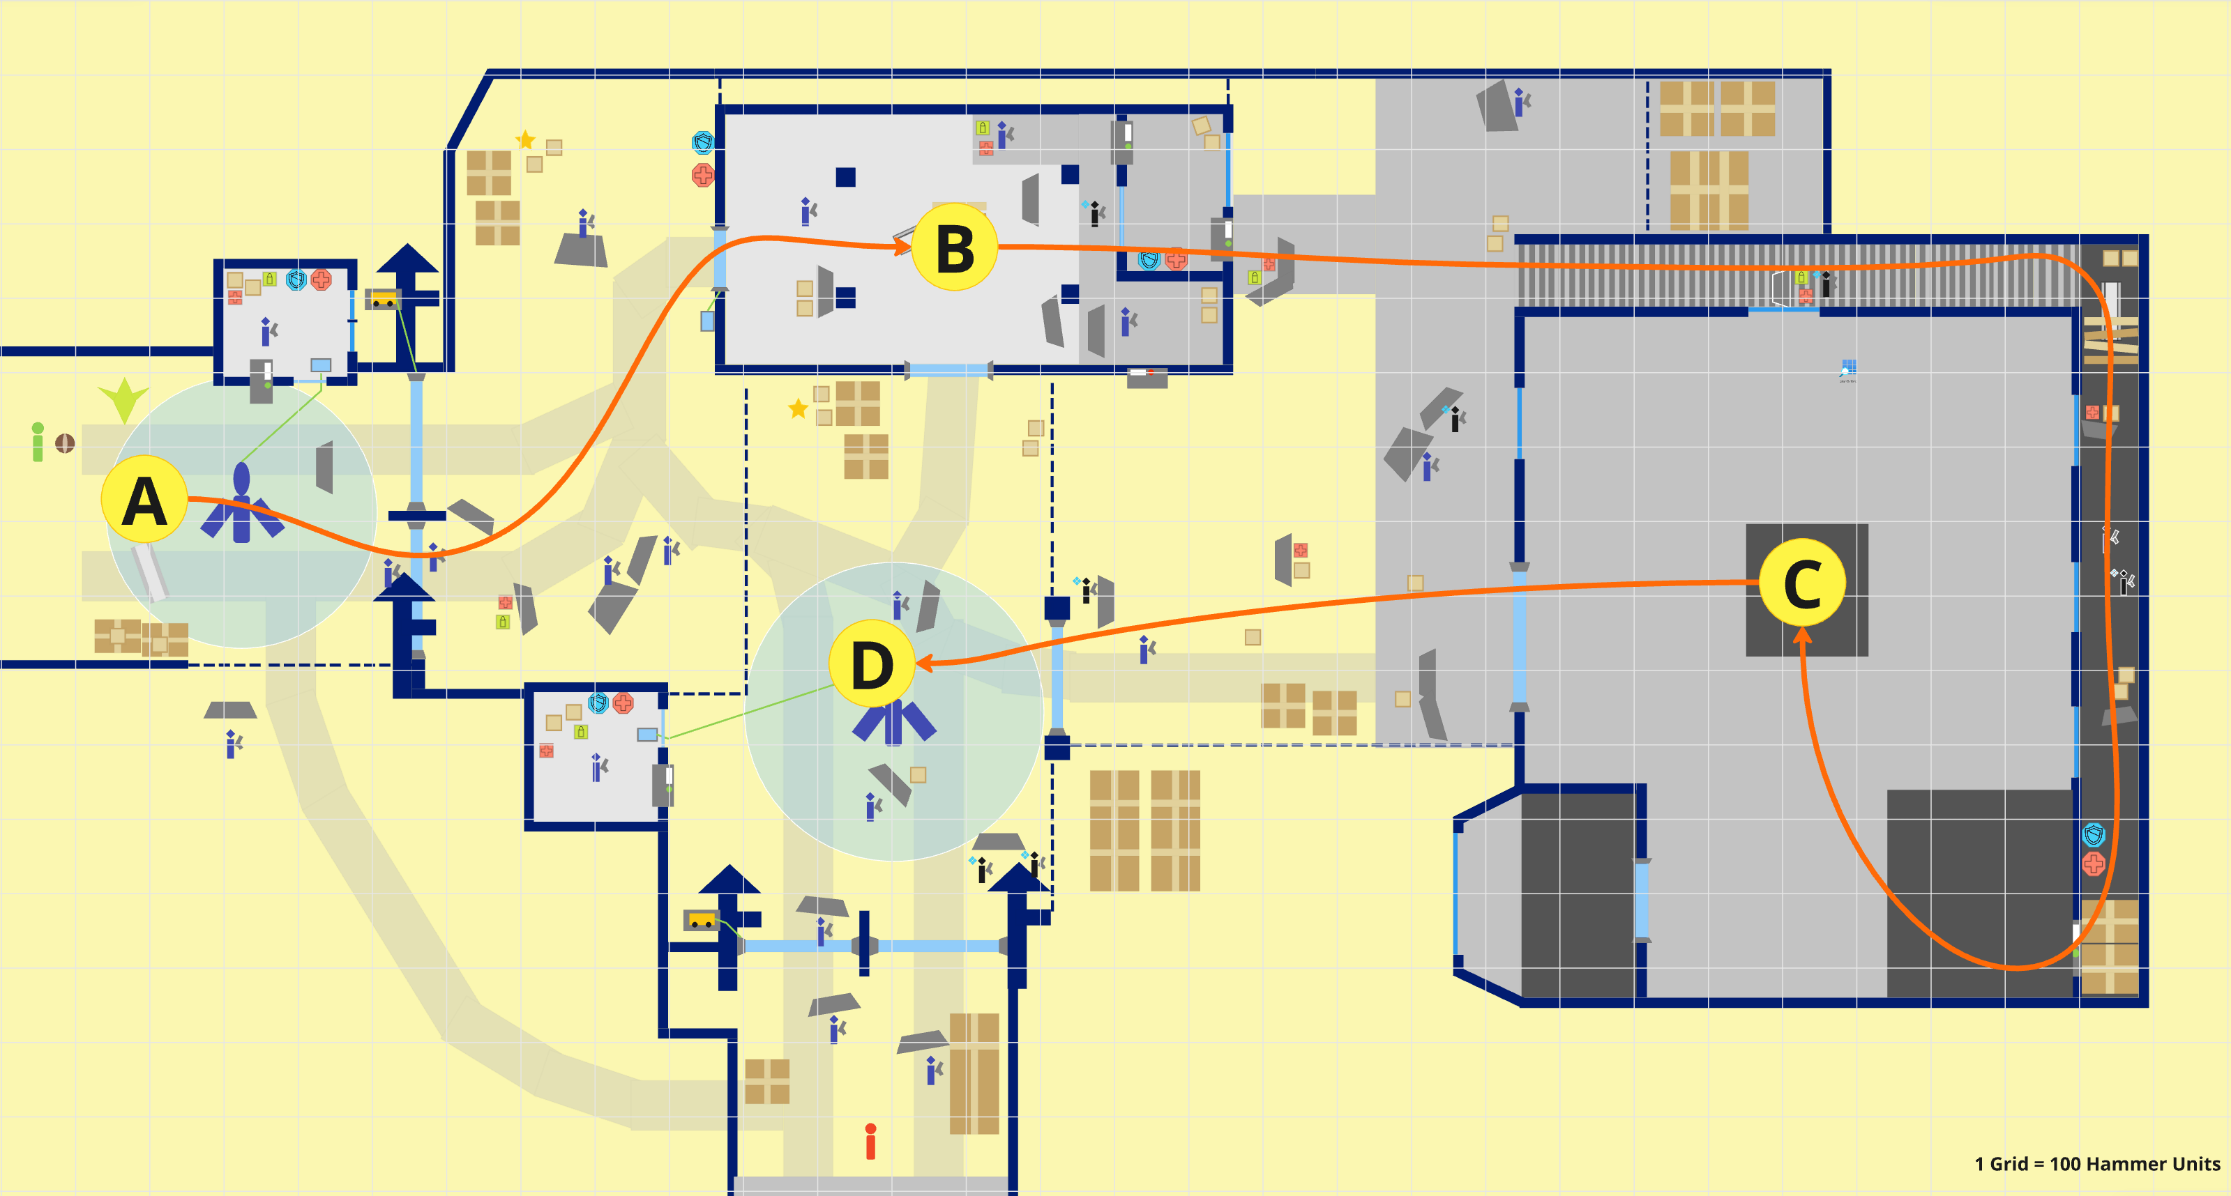
Overview Map
Figure 2: Overview Map Walkthrough [2,3]

Map Label | Gameplay Summary
A | The Player spawns on the beach by a Combine Facility, and they start with a Pheropod.  The player clears the enemies by the gate of the facility, after that, they turn off the Combine Fence and command the Antlion to shut down the Combine Fence for them, which gives them the access to the garage at B
B | The players move forward and get to the gate of a garage; after killing all the enemies in the garage, they command the Antlion to clear the rocks pressing on a panel, and use this panel to set up a ramp for them to get to the second floor of the garage, after that, they get to the exit of the garage
C | After exiting the garage, the player will see a white Combine building and a stair on the left side of it. The player successfully entered the building, collaborated with Antlion to eliminate the enemies inside, and successfully escaped the building after closing the exit with a Combine Fence
D | After getting out of the building, the players see the beach again. They turn off the Thumper and Combine Fence and manage to get to the tunnel

Level Details

Detail Maps

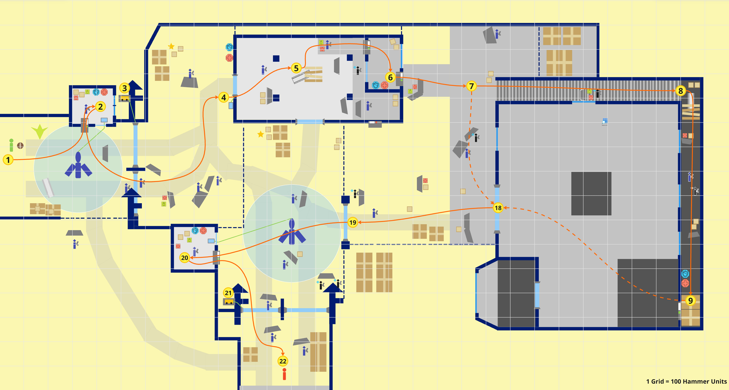
Section 1: Coast Beach
Figure 3: Section 1 Coast Beach Map Walkthrough [2,3]

Map Label / Stage | Event Summary | Event Details
1 | - Puzzle  The player spawns on the beach and managed to attack enemies | The player spawns on the beach, initially equipped with a Pheropod, Shotgun, SMG1 and Gravity Gun.
2 | - Puzzle  The player helps the Antlions to close the thumper | The player tries to command the Antlion, but it does not have any reaction because of the Thumper, so the player turns off the thumper on an interface with a button in the security booth at 2, after that, the Antlion stops fearing the Thumper
3 | - Puzzle  The Antlion helps the player to destroy the Diesel Generator at a higher place that the player cannot reach to by themselves | The player guides the Antlion to destroy the generator on the platform at 3, hence the Combine Fence turns off and the player gets access to 4 (Garage entrance)

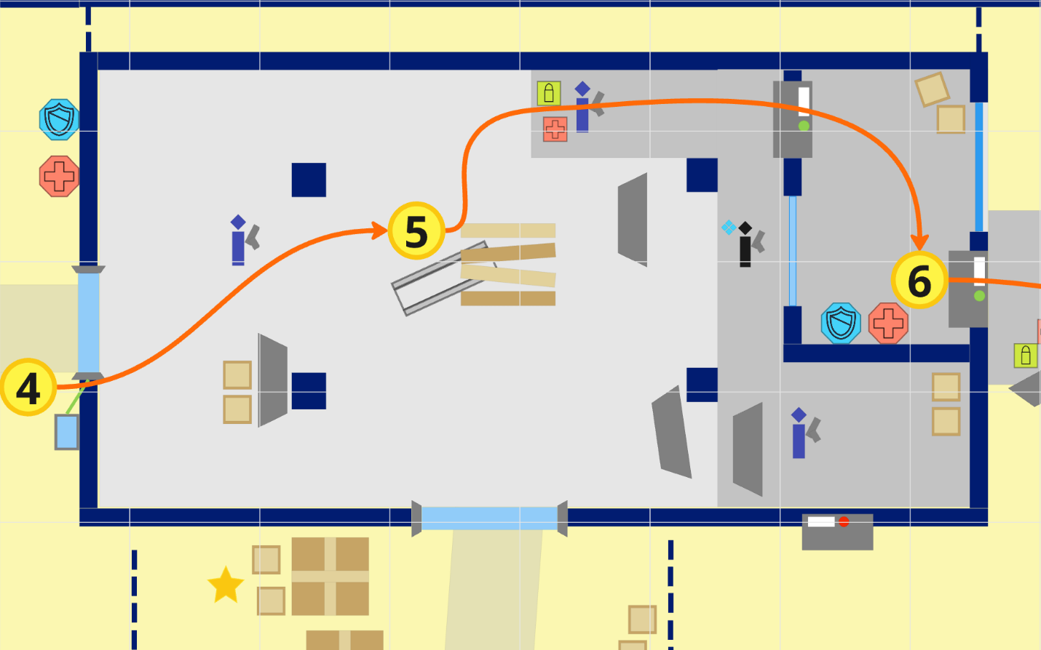
Section 2: Combine Garage
1 Grid = 100 Hammer Units
Figure 4: Section 2 Garage Walkthrough [2,3]

Map Label / Stage | Event Summary | Event Details
4 | - Encounter  - Puzzle  The player turns off the Combine Fence with the button on the interface at 4, after that, the player enters the garage | A warning occurs, with more enemies coming from the facility to prevent players from entering the building. After clearing them all, the player turns off the Combine Fence with the button on the interface and enters the garage
5 | - Encounter  - Skill Challenge  - Puzzle  The player tries to pick up a panel with the gravity gun, but it does not have any reaction. So, the player commands the Antlion to clear some rocks pressing on the panel | After clearing all the enemies in the garage, the player guides Antlion to destroy the rocks at 5, which makes the panel under them pickable for the player
6 | - Skill Challenge  The player builds a ramp with the panel | The player picks up the panel and builds a bridge to get to the second floor and exits from this garage from the Door at 6

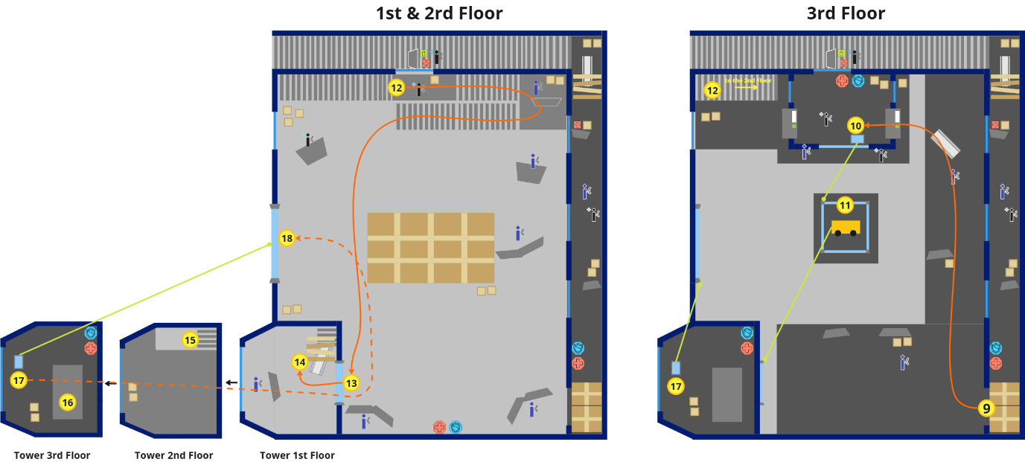
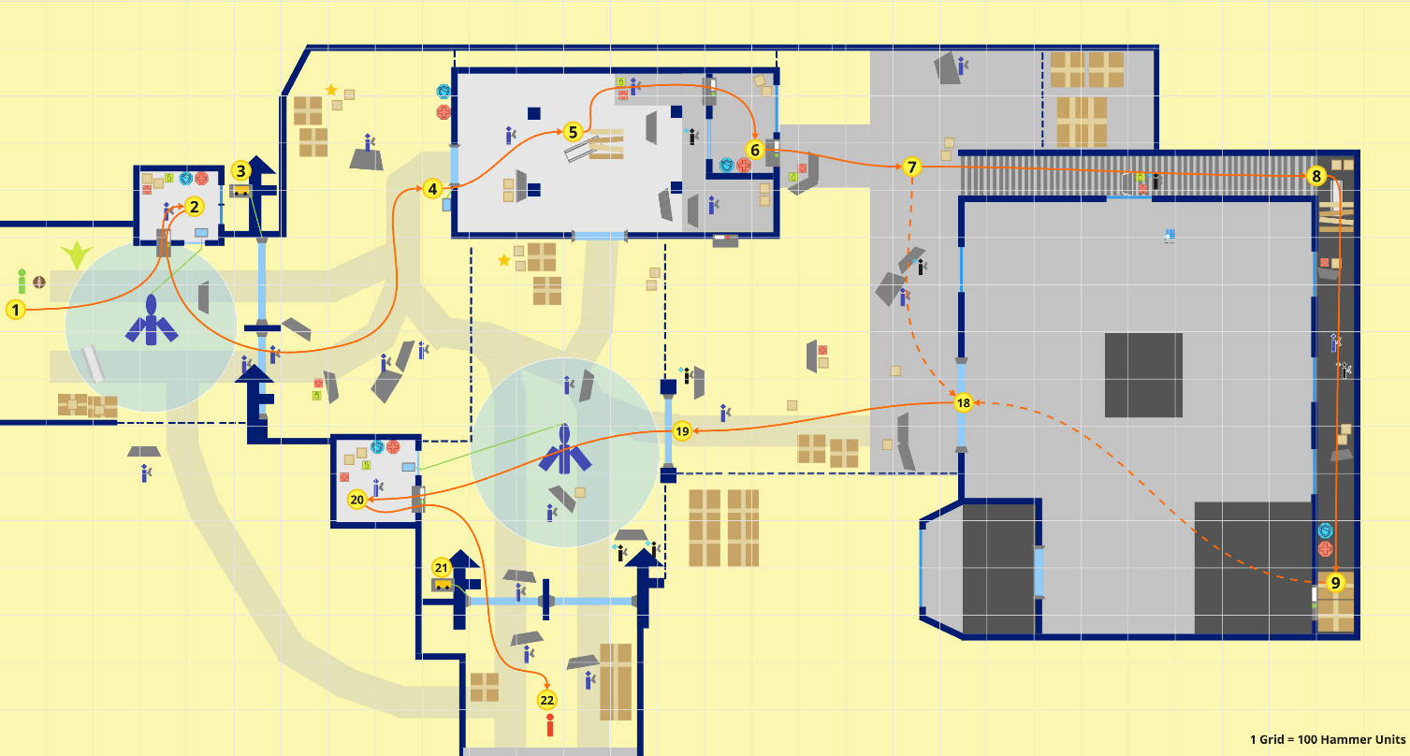
Section 3: Building
1 Grid = 100 Hammer Units
Figure 5: Section 3 Combine Building Walkthrough [2,3]

Map Label / Stage | Event Summary | Event Details
7 | - Encounter  - Narrative beat  The player follows the stair to reach the back of the building | The player gets out of the garage and clears some enemies defending the building. After that, the player tries to enter the building, however, they find that the front gate has a Combine Fence which blocks their way, so they look around and find a stair to get to the back of the building
8 | - Puzzle  - Encounter  The player gets to the back of the building and command the Antlion to clear obstacles for them | The player commands the Antlion to clear the rocks that block the door. After that, they clear some enemies on the balcony
9 | - Encounter  - Puzzle  The player successfully steals into the building with the Ventilation Duct | At the end of the balcony, the player picks up the panel (or the bin) to set up as a ramp or stepping rock to get to the platform. The player goes through the ventilation duct to get inside of the building
10 | - Encounter  - Skill Challenge  - Puzzle  The player turns off the fence around generator, which makes it possible for the Antlion to destroy the diesel generator | The player enters the room, clears enemies on the 2nd floor of the building. After that, the player finds a security room at the end of the grate way, they enter the monitoring room at 10 where they turn off the fence around generator
11 | - Puzzle  The player turns off the fence at 13 by commanding the Antlion to destroy the diesel generator connects to it | The player commands the Antlion to destroy the generator at 11, which turns off the fence at 13 (tower entrance). After that, some enemies come from the tower
12 | - Encounter  The player goes down to the 1st floor | The player goes down to the 1st floor by the stairs and clears the enemies on the 1st floor and on the stairs
13 | - Encounter  The player enters the tower | The player enters the tower, clears all the enemies defending the tower entrance. After that, the player finds that they could not use the ladder because of the rocks
14 | - Skill Challenge  - Puzzle  The player gets to the 2nd floor of the tower | The player guides the Antlion to destroy the rocks pressing on the panel, hence makes the panel pickable and make the ladder usable. After that, the player climbs to the 2nd floor of the tower
15-16 | - Skill Challenge  - Puzzle  The player set up a ramp to get to the control interface at 17 | The player uses the gravity gun to pick up a panel to set up a ramp to connect the 2nd floor and 3rd floor of the tower and gets to the control interface at 17
17 | The player turns off the Combine Fence at the exit | The player turns off the power of the exit of the building with the button on the interface and has access to the exit of the building

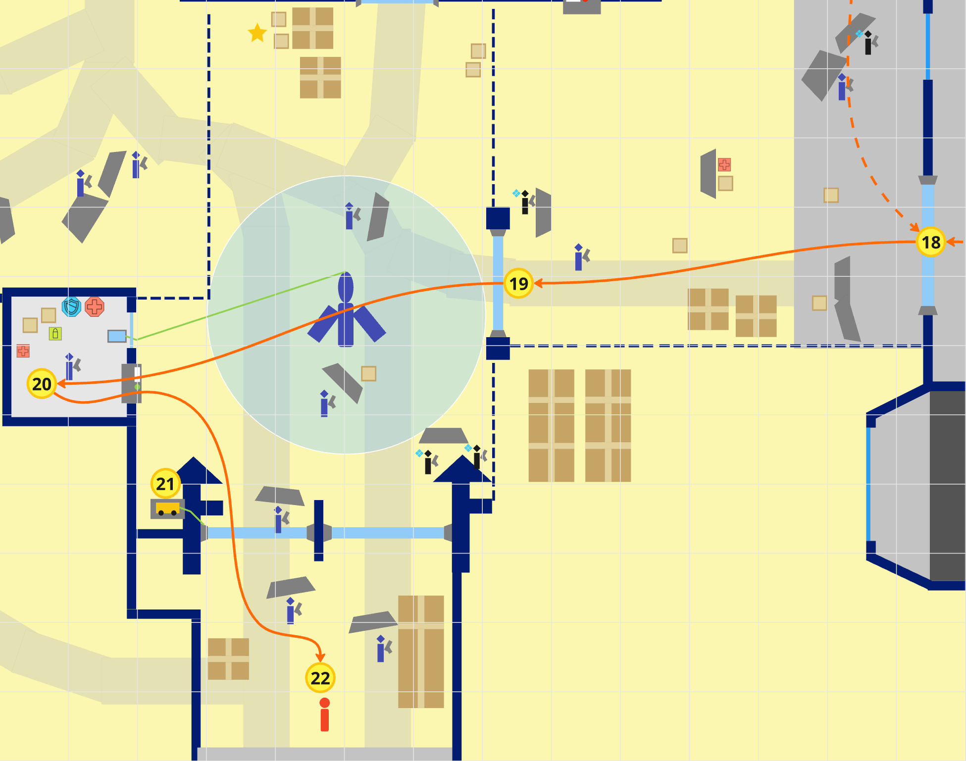
Section 4: Facility Exit Gate
1 Grid = 100 Hammer Units
Figure 6: Building Exit to Facility Exit Walkthrough [2,3]

Map Label / Stage | Event Summary | Event Details
18 | - Encounter  - Narrative beat  The player leaves the building | The player leaves the building and tries to get to the tunnel to escape from the facility, however, more enemies come out to defend the beach.
19 | - Encounter  - Puzzle  The player turns off the thumper | The player clears all the enemies defending the beach and turns off the thumper with the button on the interface in the security booth at 18
20 | - Encounter  The player eliminates the last wave of enemies coming from the tunnel | After the player turns off the Thumper, more enemies come from the tunnel at 20. The player eliminates all the enemies
21 | - Puzzle  The player turns off the Combine Fence by commanding the Antlion | The player commands the Antlion to destroy the generator at 19, which turns off the Combine Fence and the player finally have the access to the tunnel
22 | - Narrative beat  The player leaves the facility and meets Alyx at the tunnel | The player enters the tunnel and leaves the facility

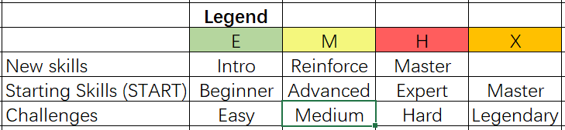
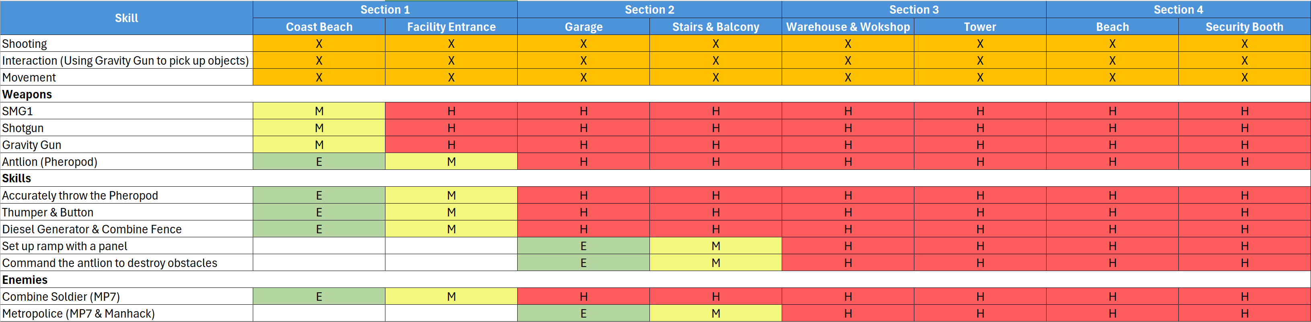
Skill Progression Chart
Figure 7: Antlion Rescue Level Skill Progression Chart [4]

Aesthetic References
The level begins on a desolate beach, which is like Sandtraps chapters from HL2. From section 2, it changes to the Combine facility. The environment is both organic and mechanical, creating spaces that blend natural landscapes with alien (Combine) architecture.
The overall lighting is dim and cold, with the beach enveloped in a gloomy atmosphere reminiscent of the bleak shores in Death Stranding.

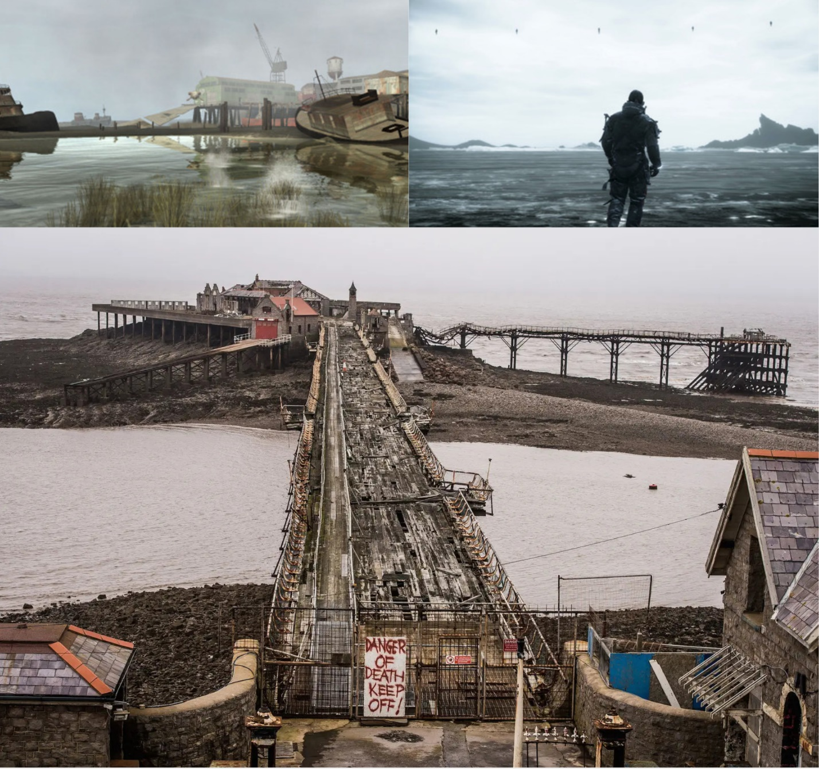
Visual Theme 1: Coast Light source and Layout
Figure 8: Coast Beach Scene Contact Sheet [5,6,7]

Visual Theme 2: Military Facility
Upon entering the Combine facility, the scene becomes slightly brighter. Different materials are used in the interior of the building to distinguish functions. The walls of the building use a deep blue material in the Combine style, and there is a vehicle under repair inside the building, along with a main control room (the tower)
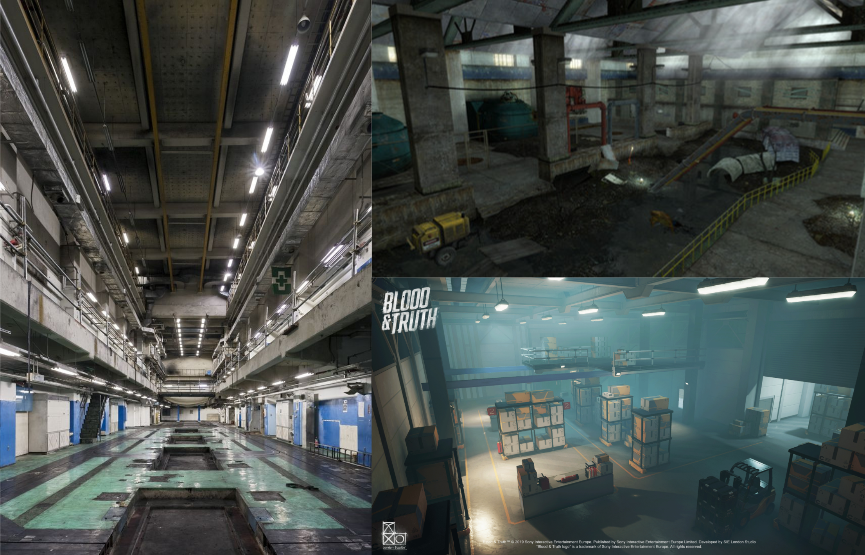
Figure 9: Interior of the building Contact Sheet [8,9,10]

References
[1] Half-Life 2. (n.d.). Screenshot of video game Half-Life 2. December 11, 2024.
[2] Lu, Jiafan. (2024.). Stickers created by author in Miro Board. RealtimeBoard. November 4, 2024.
[3] Lu, Jiafan. (2024.). Image created by author in Miro Board. RealtimeBoard. November 4, 2024.
[4] Lu, Jiafan. (2024.). Screenshot of Microsoft Excel. Microsoft. November 4, 2024.
[5] Death Stranding—PS4 Games | PlayStation—PS4 Games | PlayStation®. (n.d.). Retrieved November 4, 2024, from https://www.playstation.com/en-us/games/death-stranding/
[6] The Coast. (n.d.). Half-Life Wiki. Retrieved November 4, 2024, from https://half-life.fandom.com/wiki/The_Coast
[7] “There’s A Stunningly Creepy Pier In Somerset That You Have To See.” Accessed: Dec. 11, 2024. [Online]. Available: https://www.buzzfeed.com/matthewtucker/theres-a-stunningly-creepy-pier-in-somerset-that-you-have-to?epik=dj0yJnU9UmYzck1rSUxoQkQ5bGdfa2Y2Z2VaOXg0OXo5S01mSy0mcD0wJm49dktfRms2dTM3QllHeWpZR2dHU3VLdyZ0PUFBQUFBR2RaTXQ0&new_user=true&newsletter_modal=true
[8] “OpenA » TABLOID.” Accessed: Dec. 11, 2024. [Online]. Available: https://www.open-a.co.jp/portfolio.php?p=207
[9] Abandoned warehouse, now a home for Xenian wildlife. (2023, September 17). LambdaGeneration. https://community.lambdageneration.com/half-life/post/c0fjdoevg8g
[10] “Blood & Truth HQ Facility, Jamie Perrin,” ArtStation. Accessed: Dec. 11, 2024. [Online]. Available: https://www.artstation.com/artwork/v1xxBE

Appendices

Appendix A: New Skills / Gameplay Mechanics

Command the Antlion to destroy the Diesel Generator and Obstacles
Antlions will not only serve as allies helping the player eliminate enemies but will also assist in removing obstacles along the way. This includes:
- Destroying (shutting down) diesel generators to disable the Combine Fence.
- Destroying rock or sand obstacles to allow the player to pass through.
The player needs to throw the Pheropod toward the desired location (such as behind the obstacle, or near the Diesel Generator). The Antlions will then proactively clear the obstacles on the path or the Diesel Generator on a platform.

Appendix B: Context Detail

General Context
Plot Location: This level is set in the world of "Half-Life 2," following the "Sandtraps" chapter and before Freeman and Alyx use the teleporter to escape Nova Prospekt. At that stage, the player has learned to use the Pheropod to control Antlions.
Challenge: The levels Combine combat, puzzle-solving, and strategic use of Antlion's abilities, adding depth and difficulty to the game. Players need to cleverly utilize the environment and Antlion to fight against Combines. Due to the varying abilities of players and Antlions, this level requires players to collaborate with Antlions to solve puzzles in addition to combat.
Aesthetics: The level presents a gloomy, desolate beach environment (darker than the coast in the game) and a Combine Facility. The overall lighting is dim, creating a tense atmosphere that aligns with the game's overall aesthetic style.

Backstory
Under the rule of the Combine, living beings suffered brutal oppression. The Combine had established many secret laboratories to conduct cruel experiments on Antlions, attempting to transform them into more lethal biological weapons.
According to the intelligence from Resistance, a Combine facility on the coast has preserved relevant confidential documents. To weaken the Combine's power and prepare for the upcoming battle, Gordon decides to infiltrate the facility at dawn.

Aftermath
After intercepting the relevant documents from the facility, the Resistance located the related laboratories and destroyed them one by one. More and more trained Antlions became allies of the Resistance, providing strong support against the Combine.

Appendix C: Character Descriptions

NPC 1
N/A

Appendix D: Dialog Flow

NPC 1
N/A

Appendix E: Development Risks

Map Label | Description/Mitigation | Type | Priority
5 | If the panel at 5 is thrown out of the room, it may cause a Showstopper. So, it needs a respawn mechanic to make sure that the player could always have it in the room. | Scripts | High

Appendix F: Key Asset Needs
Description | Type | Priority
To make it reasonable for the Antlion to respawn in the interior scenes of the building, some pits need to be set up on the ground. Therefore, it is necessary to find the corresponding model, and the material of the model needs to match the material of the ground. (Maybe you can refer to the Nova Prospekt chapter in the game.) | Mesh/Texture | Medium

