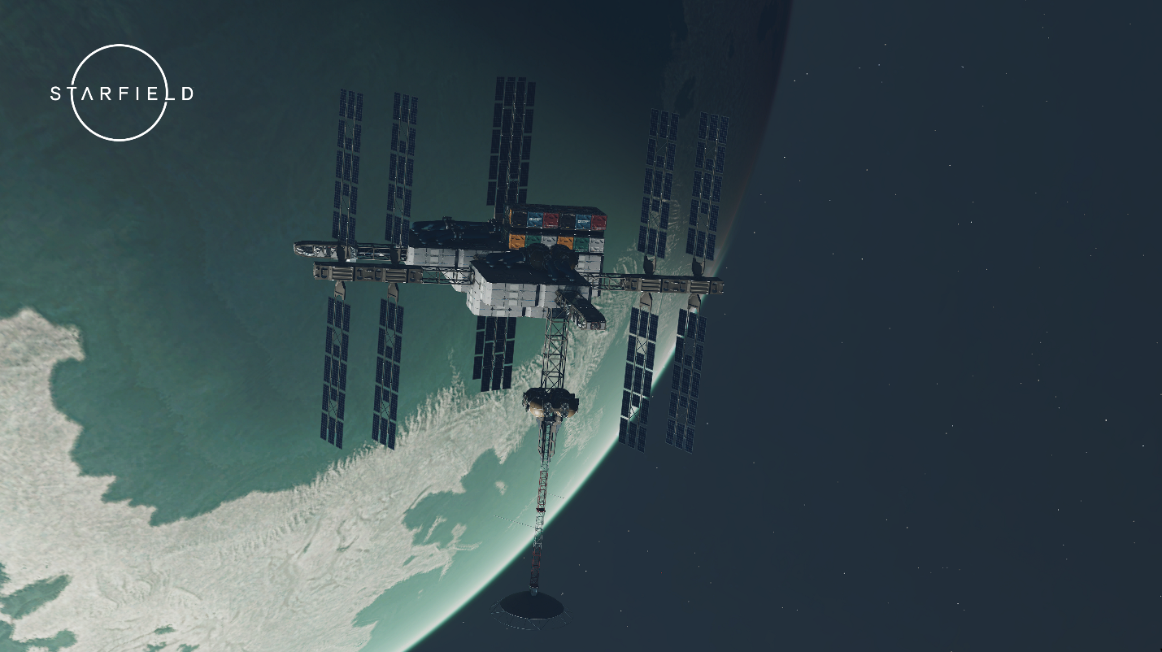

Starfield: Silent Shift
  - Version 1.0
Designer: | Roy Lu
Document Date: | 5/31/2025
Intended Level Delivery Date: | 7/22/2025

Document Revisions Table
Version | Description | Requestor | Date
1.0 | Initial Document | Professor. Brandon Stephens | 5/31/2025

Table of Contents
Table of Contents 2
Table of Figures 3
Level Summary 4
Quick Summary 4
Level Feature Overview 4
Development Schedule 4
Level Overview 6
Overview Map 6
Level Details 7
Detail Maps 7
Section 1 7
Section 2 9
Section 3 11
Aesthetic References 13
Bright Space Station (power on) 13
Dim, Chaotic and disorganized (power off) 13
References 14
Appendices 15
Appendix A: New Skills / Gameplay Mechanics 15
Adjustable gravity system 15
Appendix B: Context Detail 16
General Context 16
Backstory 16
The course of the incident 16
Appendix C: Character Descriptions 18
NPC 1: Rou (Victim) 18
NPC 2: Wen 18
NPC 3: Johnny 18
NPC 4: Victor 18

Table of Figures

Figure 1: Overview Map [1] 6
Figure 2: Section 1 Map [1] 7
Figure 3: Section 2 Map [1] 9
Figure 4: Section 3 Map [1] 11
Figure 5: Power-On Station Interior Reference [2] 13
Figure 6: Power-Off Station Interior Reference [2] 13

Level Summary

Quick Summary
“Silent Shift” is a single-player level developed for Starfield. On a research space station, during a sudden power outage, Chief Scientist Rou is found dead under suspicious circumstances. With no surveillance available, players must explore rooms and the crime scene, analyze logs and data in terminals, and interrogate the suspects. Gravity is a key mechanic in this level, allowing access to hidden areas and reconstruction of crime. The level blends environmental storytelling, exploration, and deduction.

Level Feature Overview
Category | Sub-Category | Feature List
Player | Player Weapons | - N/A (This level does not require weapons)
 | Player Skills/Abilities | - Pick locking  - Jetpack
AI | Enemies | - N/A (There are no enemies in this level)
 | Friendlies | - All NPCs are neutral
Challenges | Gameplay Themes | - Zero-gravity  - Puzzle-solving  - Deduction
 | Obstacles/Hazards | - Locked Room  - Areas that require zero gravity to enter
 | New/Unique Gameplay | - Gravity based Puzzle-solving
Context | Where Fits in Game | - Standalone level  - Ideally after the Unearthed chapter in the base game, players have gained some understanding of zero-gravity space and movement
 | Challenge Fit | - Ideally players above level 20 who have already learned lockpicking, jetpack  - For players without relevant skills, Quest Giver (the police) will provide suit with jetpack
 | Additional Info | - The location of the space station is near Jemison
Aesthetics | Major Visual Themes | - Research Star Station  - Sterile Hypertech
 | Setting/Mood | Crime Scene  - Dim  - Abandoned  Other scenes  - Bright

Development Schedule
Milestone | Date
LDD | 6/1/2025
Whitebox | 6/8/2025
Initial Gameplay | 6/22/2025
Gameplay Complete | 7/6/2025
Aesthetics | 7/13/2025
Launch | 7/22/2025

Level Overview

Overview Map
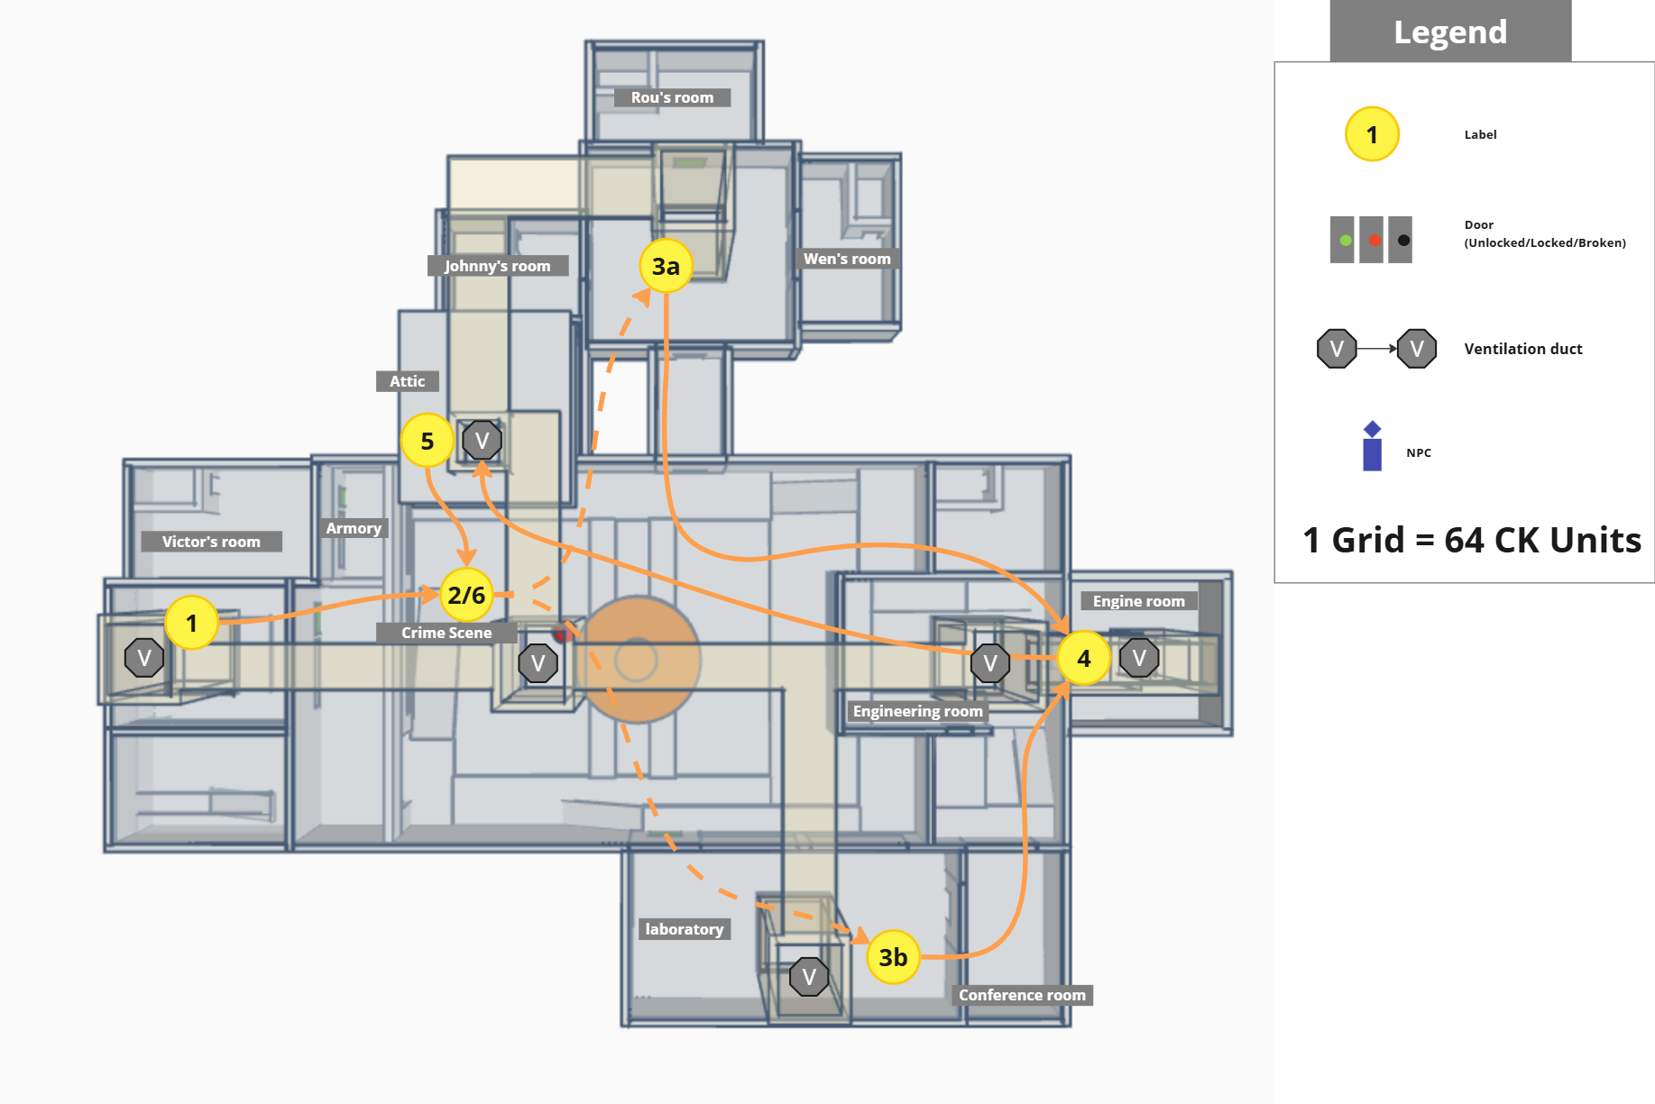
Figure 1: Overview Map [1]
Map Label | Gameplay Summary
1 | Player enters the space station.
2 | The player arrives at the crime scene, gathers information from the Police and three suspects, and investigates the body of the victim.
3a | The player investigates each person's room to find some clues.
3b | The player uses a shortcut to enter the engine room.
4 | The player enters the ventilation duct by turning off gravity.
5 | In Johnny's room mezzanine, the player found crucial evidence.
6 | The player identifies Johnny as the criminal and debates with him.

Level Details

Detail Maps
Tinker CAD：https://www.tinkercad.com/things/9SgoB5qLLnC/edit?returnTo=%2Fdashboard&sharecode=T1R7nIVJq0T8KGF_cRxRy7ZBdEDMnrUDw1c1h5Buq3g

Section 1
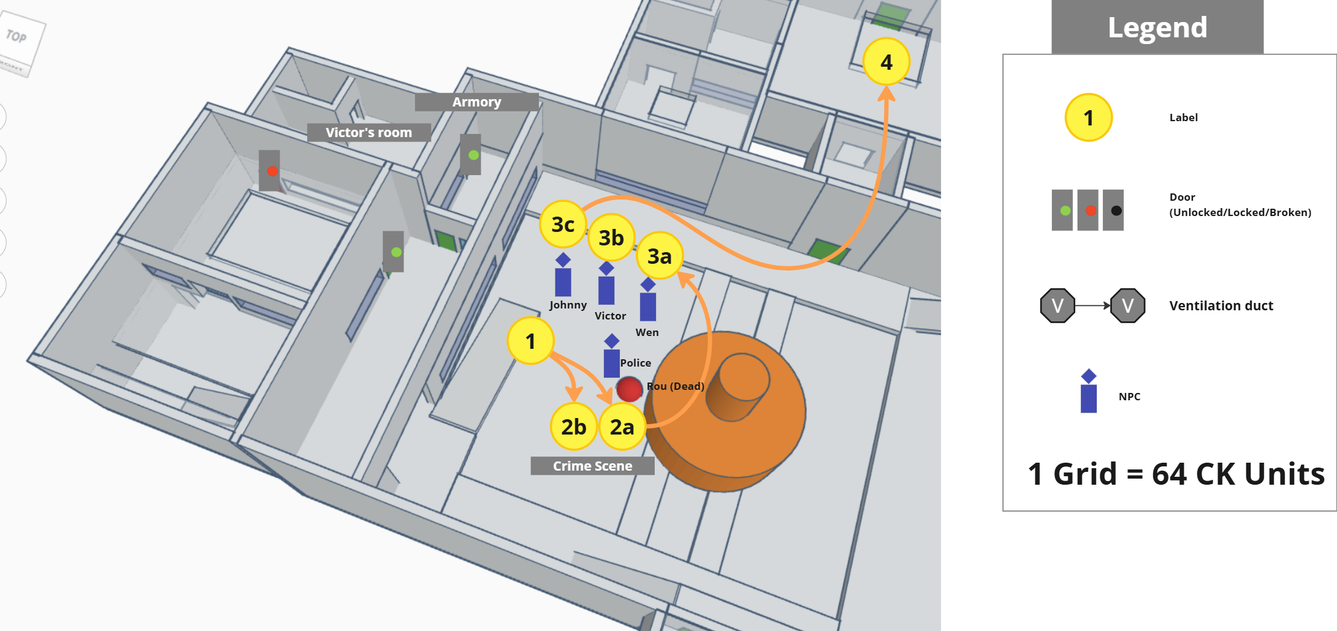
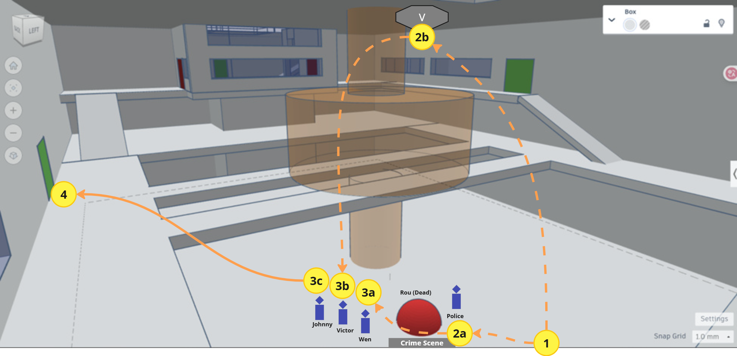
Figure 2: Section 1 Map [1]

Map Label / Stage | Event Summary | Event Details
1 | The player obtains relevant information about the incident from the police and suspects | Player gets some information:  1. There was a power outage at the time of the incident, causing gravity to disappear temporarily, but it was later restored  2. The victim is the chief scientist on the space station  3. The incident occurred at 4 a.m.  4. The victim was working the night shift at the time
2a | The player observes the environment | By observing the crime scene, the player noticed blood dripping from the ventilation opening on the ceiling above, leading to the suspicion that the crime did not take place on the ground. However, the player could not reach the ceiling.
2b | The player investigates the corpse and talks to the police | The player obtains a report of the deceased from the police  Name: Rou  Occupation: Chief Scientist, Biologist  The report shows the deceased's body is contorted  The deceased had gunshot wounds  The bullet caliber was .45 Caliber ACP
3a | Talk with suspect Wen | Occupation: Systems Engineer  Relationship with the deceased: Colleague and partner  Suspicion: Has access to the electromechanical room, power was cut off at the time of the incident, so she is a suspect. Also, Wen is responsible for electromechanical equipment maintenance and has access to the electromechanical room
3b | Talk with suspect Victor | Occupation: Security  Relationship with the deceased: Colleague  Suspicion: The only person with a weapon on the space station  Responsible for the security of the space station, owns a private armory
3c | Talk with suspect Johnny | Occupation: Research Assistant  Relationship with the deceased: Assistant  Suspicion: Had a financial dispute with the deceased, skilled in using chemicals. He was the deceased's research assistant, formerly an outstanding chemist who left the Freestar Collective due to academic misconduct and came to UC to make a living, only able to work as an assistant, insisting that Rou committed suicide.

Section 2
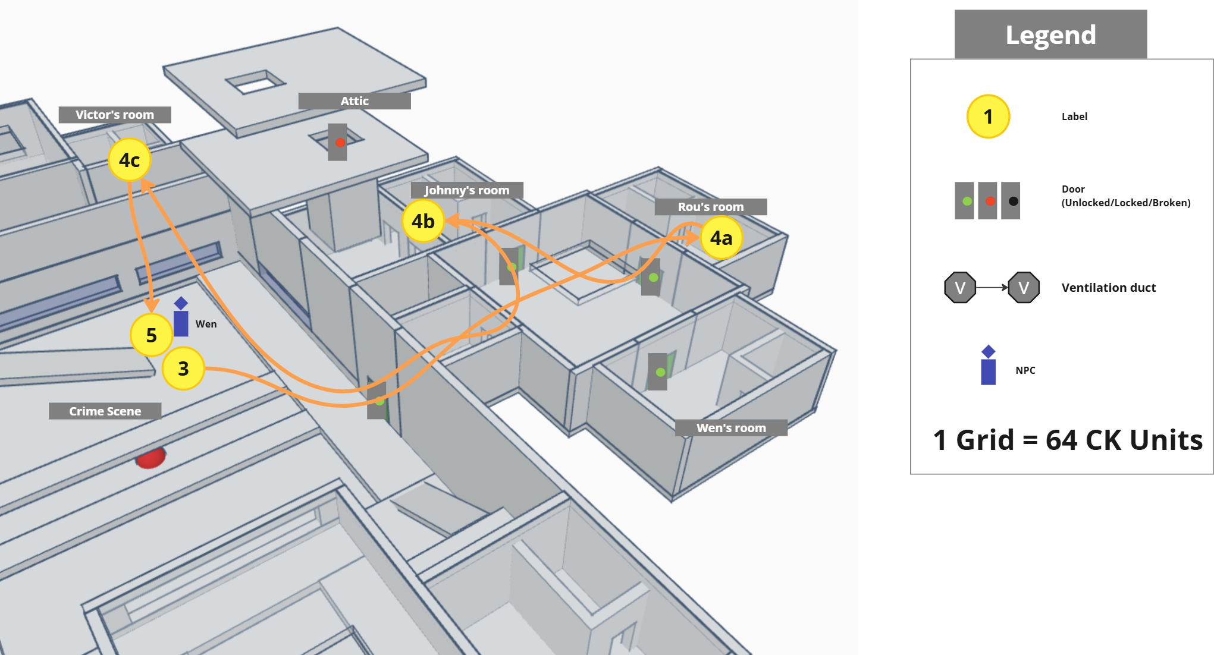
Figure 3: Section 2 Map [1]
Map Label / Stage | Event Summary | Event Details
4a | The player investigates Rou's room | The player finds Rou's log: I discovered that Johnny was conducting illegal experiments, and I hinted to him not to continue. It's too oppressive here. Once our research results are accepted, Zhang Wen and I will return to the settled star system, buy a house, and live a peaceful life.  The player checks the access records of the door from the terminal and finds that Johnny did not return to his own room all night yesterday, he was on patrol duty in the station.
4b | The player investigates Johnny's room | The player discovered a large amount of medicine in Johnny's room  There is an attic overhead, but it was locked from the inside and weighed down by heavy objects  The player checks the access records of the door from the terminal, showing that Johnny was in his own room at the time of the incident and did not enter or leave the room
4c | The player investigates Victor’s room and the armory | The player discovered that a gun was missing from the armory, but Victor insisted that he had only lost the gun. He was afraid of being dismissed, so he didn't report it at the time, suspecting it had been stolen.  There are no guns using .45 Caliber ACP ammo in the armory, which is different from the type of bullets found at the crime scene.
5 | The player attempts to recreate the gravity conditions at the time of the incident | Wen informed the player that the station's power system is controlled by equipment in the engineering room, and she has the key to getting there but has lost it.

Section 3
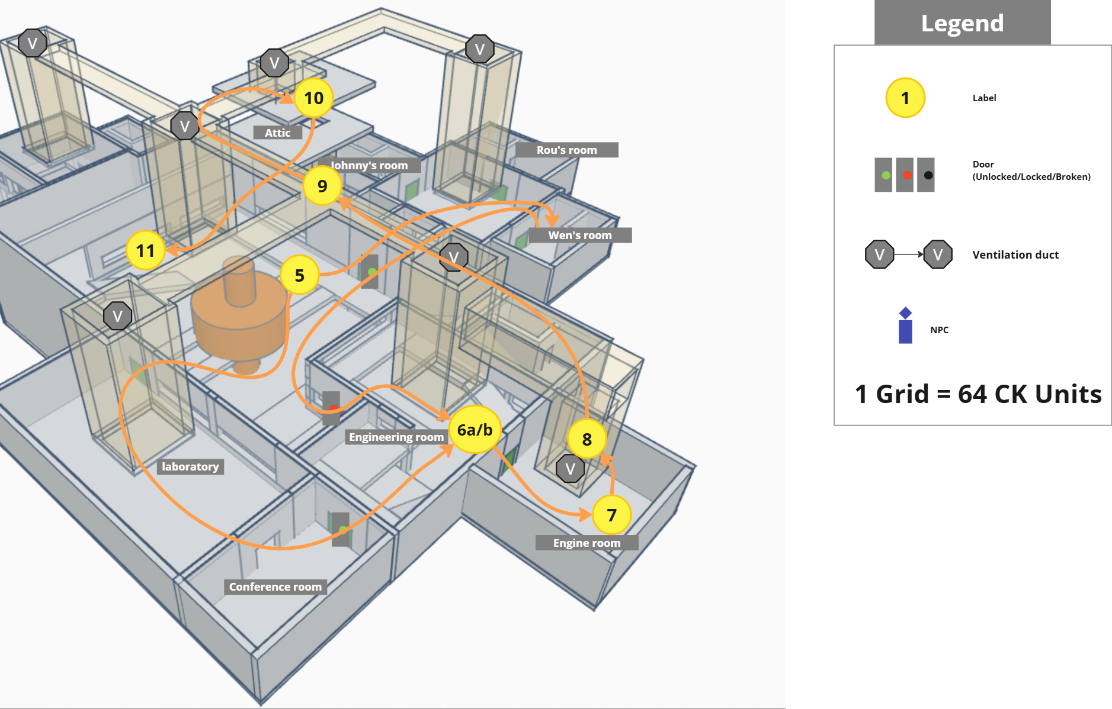
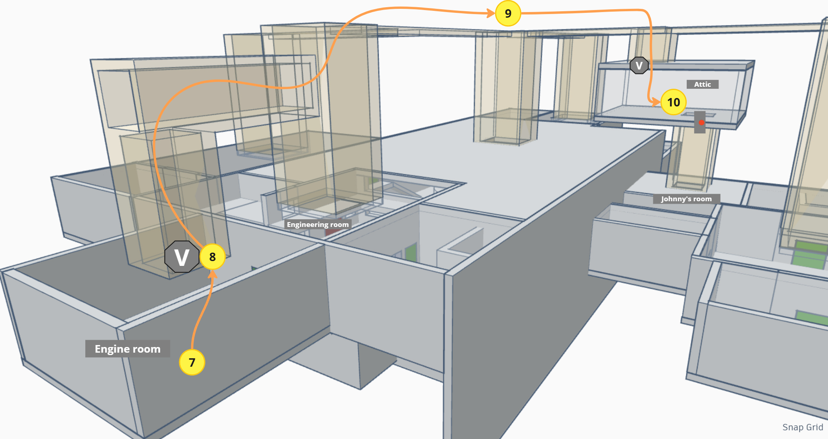
Figure 4: Section 3 Map [1]
Map Label / Stage | Event Summary | Event Details
6a | The player uses a shortcut to enter the engineering room | Players find other routes to enter the engineering room through the laboratory and conference room.
6b | The player investigates Wen's room, and finds the key and successfully entered the engineering room | The player finds the key in Zhang Wen's room  The player checks the access records of the door from the terminal, showing that Wen was in her own room at the time of the incident and did not enter or leave the room
7 | The player investigates the Engine Room | By inspecting the whiteboard, it was learned that this is the place where scientific waste is processed, and this waste is discharged into space along with fuel.  The player found an M1911 (Old Earth Pistol using .45 Caliber ACP Ammo) in the trash  There are bloodstains on the ground, indicating that the deceased was once here. Therefore, the player suspects the body was moved, but everyone has an alibi. Thus, there are only two possibilities:  1. Someone was able to enter this engine room without going outside their own room  2. Rou committed suicide.
8 | The player noticed bloodstains on the ventilation duct above
9 | The player disables gravity to enter the ventilation duct | The player uses the engineering room's equipment to turn off the power, allowing them to enter the ventilation duct in zero gravity
10 | Player enters Johnny's room attic | Following the bloodstains along the ventilation duct, the player arrives at an attic storing many contraband items and biological samples. This leads to Johnny's room, where there is some .45 Caliber ACP
11 | The player points out to the police that Johnny is the murderer | The player identifies Johnny as the murderer and reveals his motive and method for the crime.

Aesthetic References
“Silent Shift” is set in a research space station with a clean, organized layout that makes environmental clues (Bloodstains) more noticeable by the player. There is a huge machine in the middle of the space station. When the power is on, the station is well-lit and orderly. After the player disables the power, the environment shifts, the lights flicker, debris floats, and the scene becomes disoriented.

Bright Space Station (power on)
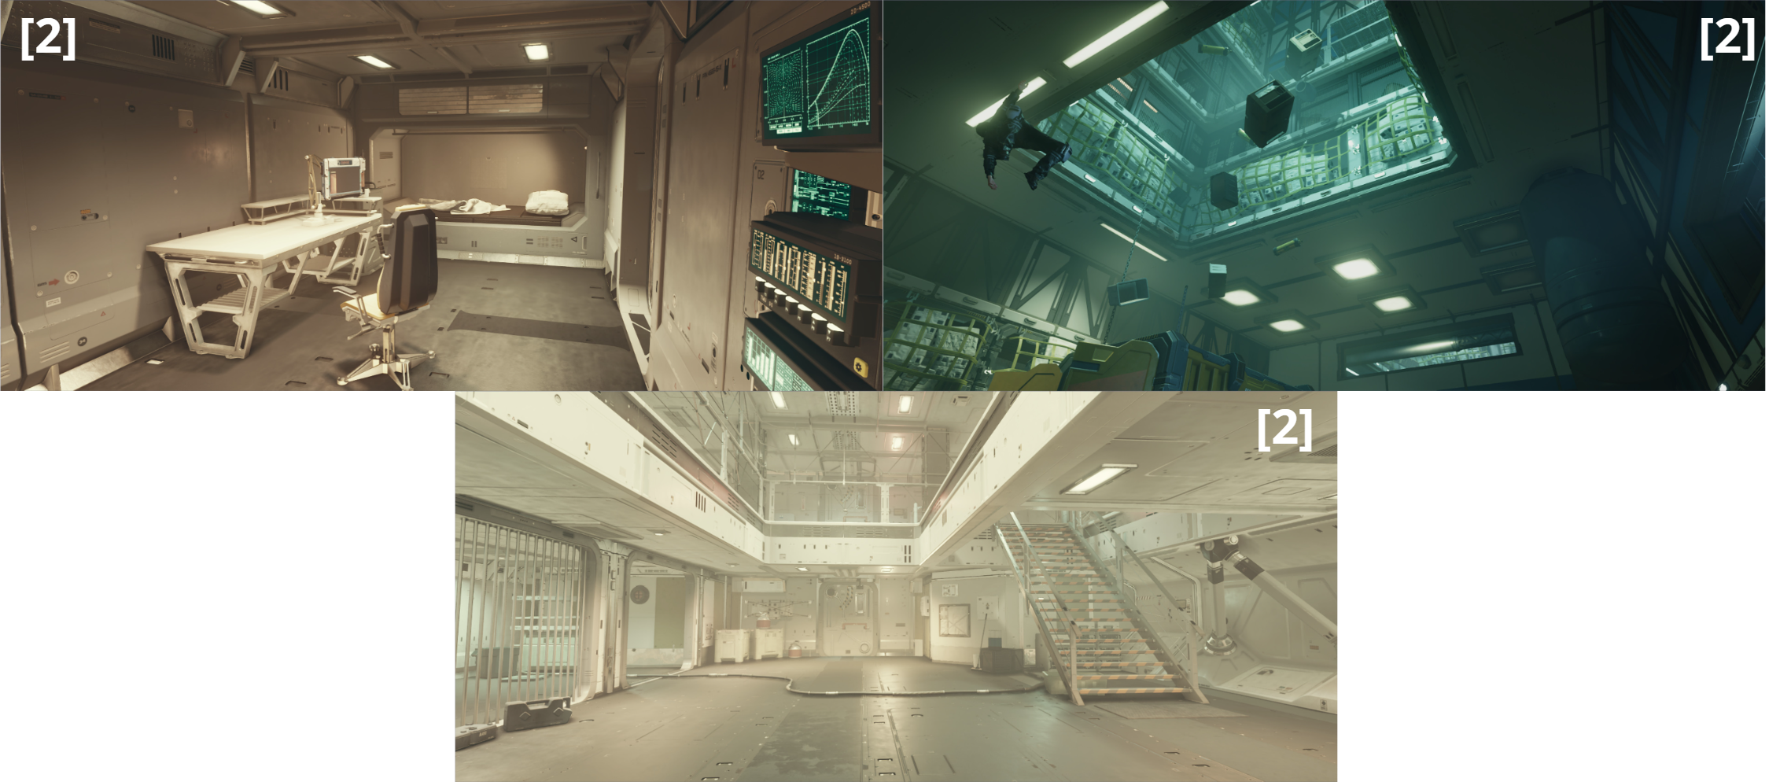
Figure 5: Power-On Station Interior Reference [2]

Dim, Chaotic and disorganized (power off)
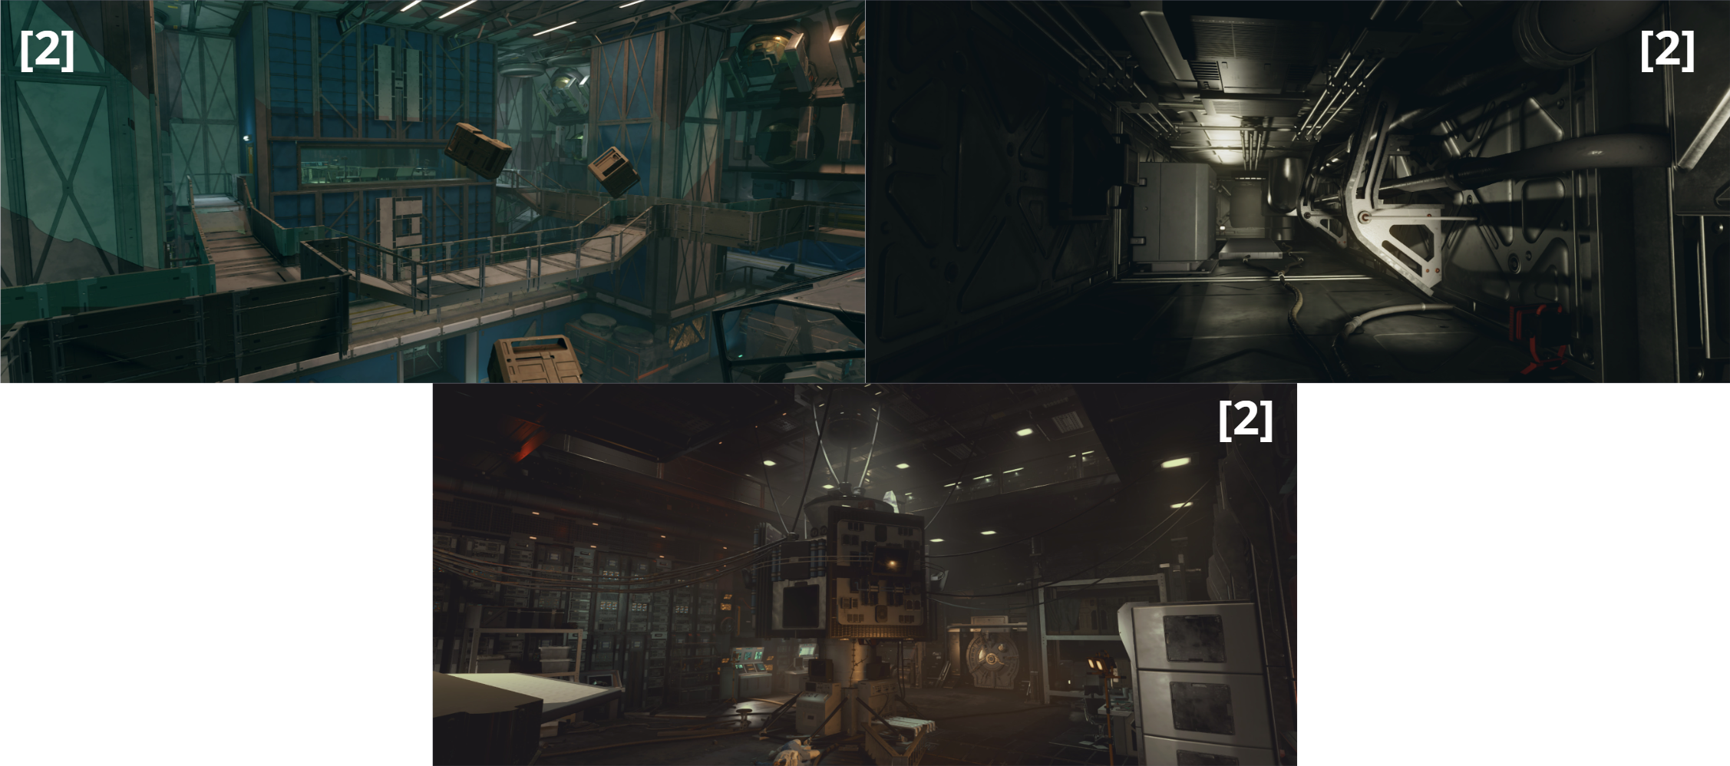
Figure 6: Power-Off Station Interior Reference [2]

References
[Cover Image] Lu, Jiafan. (2025). Screenshot from Starfield, captured by the author. Bethesda Game Studios, PC. May 31, 2025.
[1] Lu, Jiafan. (2025). Level Walkthrough Map Created by author in Miro Board. RealtimeBoard, Inc, 2011. June 1, 2025.
[2] Lu, Jiafan. (2025). Screenshot from Starfield Creation Kit, captured by the author. Bethesda Game Studios, PC. May 31, 2025.

Appendices

Appendix A: New Skills / Gameplay Mechanics

Adjustable gravity system

Function
The player uses a terminal in the engineering room to toggle gravity/power between two states (0 and 1/On and Off)

User Interface
Use the standard Terminal User interface style in Starfield
- Primary Menu
  - Title: Power Control
Description: Current Power Status (“On” / “Off”)
- Secondary Menu
  - Turn Power On
  - Turn Power Off

Feedback
- Player: With gravity turned off, the player floats and can move in any direction, including the access of the ventilation duct.
- Environment: Objects float when gravity is off, and they fall again once gravity is re-enabled.
- Lighting: the lighting will also switch from normal intensity to red-toned emergency lighting.

Appendix B: Context Detail

General Context
Silent Shift takes place aboard a remote research space station owned by UC orbiting an uninhabited planet. The station specializes in studying bio neural interface technology. It operates with a small crew and limited oversight from UC.

Backstory
Rou, the Chief Scientist and lead of the UC neural-interface project, was found dead under suspicious circumstances during a brief power outage on the space station.
Rou had been on duty the night before, and his body was discovered the following morning. Although the corpse was found on the floor of the central hall, multiple pieces of evidence suggest that the incident may not have occurred at that location. The station’s surveillance systems were disabled during the blackout, and all three surviving crew members have partial alibis. Therefore, UC security officers believe Rou committed suicide.
UC authorities turn to the player for assistance in investigating the case. As the player delves deeper, a series of inconsistencies and troubling details begin to emerge.

The course of the incident
Johnny, a research assistant, murdered his supervisor, Rou.
A former citizen of the Freestar Collective, Johnny was once a gifted chemist and held the position of chief scientist at a research institution in FC. However, he was dismissed and prosecuted after using his position to manufacture addictive chemical substances for profit and for trafficking his team’s research data. To escape legal consequences, he fled to UC and took a job as a research assistant under Rou’s project.
In addition to his official work, Johnny conducted illegal experiments nightly in a hidden attic above his room (originally an emergency storage unit). There, he produced and used contraband substances, frequently disposing of chemical waste through the space station’s ventilation system. He also maintained dealings with drug traffickers in Neon City. Although Rou was aware of Johnny’s activities, he chose not to intervene. Tired of his work, Rou simply hoped to finish the project, collect his share of the research bonus, and retire peacefully with his partner, Wen.
In the early hours of the incident, Johnny was attempting to dispose of a batch of chemical waste by mixing it into the fuel system via the engine room’s disposal port. Rou, who was on night duty in the lab, heard the noise and followed him, and saw everything. Realizing he had been caught, Johnny killed Rou with his pistol (also stole from Victor). He then shut down the station’s power and disabled gravity in the engineering room, allowing him to hide the body of Rou inside the ventilation duct, where it drifted weightlessly into the upper section of the central hall. When gravity was restored later, the body fell to the floor, appearing as if it had died there.

Johnny crawled back to his room through the ducts and staged a perfect alibi, making it appear that he had never left his own room.

Appendix C: Character Descriptions

NPC 1: Rou (Victim)
Description | Talented scientist
Background | Chief Scientist in the Station
Goals/Motivation | After completing the acceptance of the experimental results, he wishes that he and his partner Wen could go to settle on a planet for a stable life
Personality/Archetype | Full of a sense of justice
Relationships | Wen's partner and Johnny's boss

NPC 2: Wen
Description | Systems Engineer
Background | Talented spacecraft systems engineer
Goals/Motivation | No obvious motive
Personality/Archetype | Optimistic, emotional
Relationships | Rou's partner

NPC 3: Johnny
Description | Research Assistant
Background | Rou's research assistant and also a talented chemist. Jealous of Rou's success, he conducts some unsavory experiments in the attic of his own room.
Goals/Motivation | Caught by Rou while handling illegal experimental materials in the engine room  Once stole an M1911 pistol from Victor's armory
Personality/Archetype | Selfish, taciturn
Relationships | Rou's assistant

NPC 4: Victor
Description | Security
Background | Victor is a lazy security who also like to drink alcohol
Goals/Motivation | He collected many weapons  He often loses control after drinking alcohol
Personality/Archetype | Lazy, simple-minded
Relationships | Rou's friend

